Docker & Docker HUB

Some docker commands

1.To check the version of the docker

2.To create a container laye over a specified image

Docker run container name.

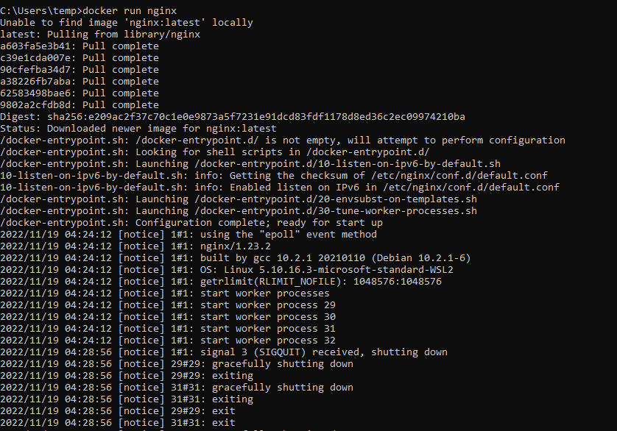

3.This command is used to list all containers present.

Docker ps -all



4.To get the details of the image

Docker images



5.To search repository.

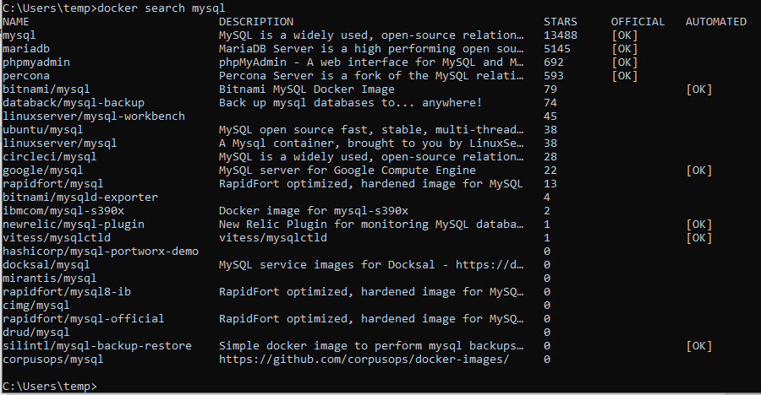

6.to pull specific image from the docker hub.

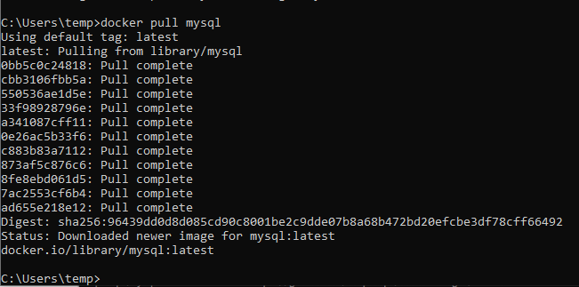

7.to stop the container

Docker stop containerid or name



8. Again to start the container

Docker start containerid or name



9.To know all the running apps in the container

Docker ps -a



10. To check all the logs of the container

Docker logs

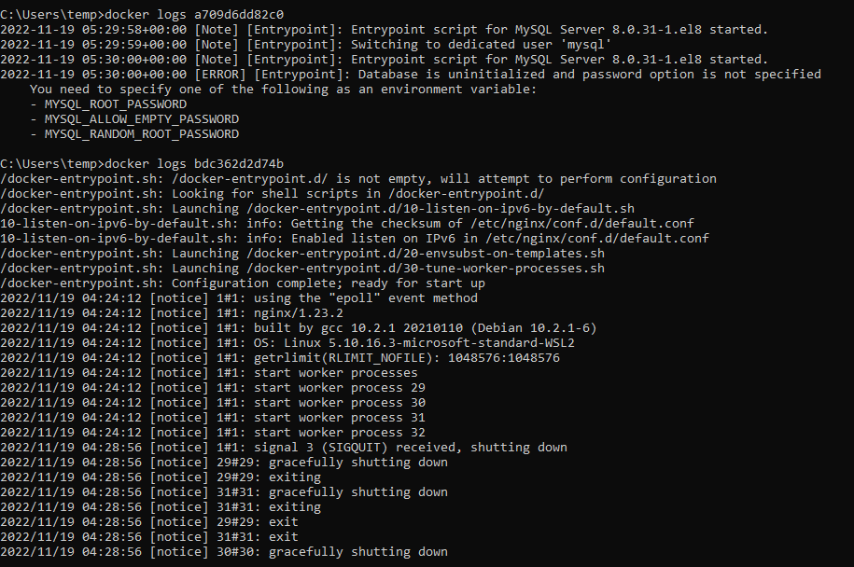

11.To login to your docker login

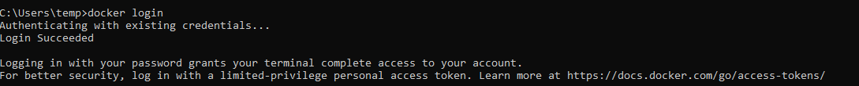

12.To delete the tag forcefully.

13.To stop the container immediately

docker kill container id.



14.sign in with your own username and password

15.giving tag to your repository

After

16. pushing the repo in your account

TASK-2

Running hello world in your port locally

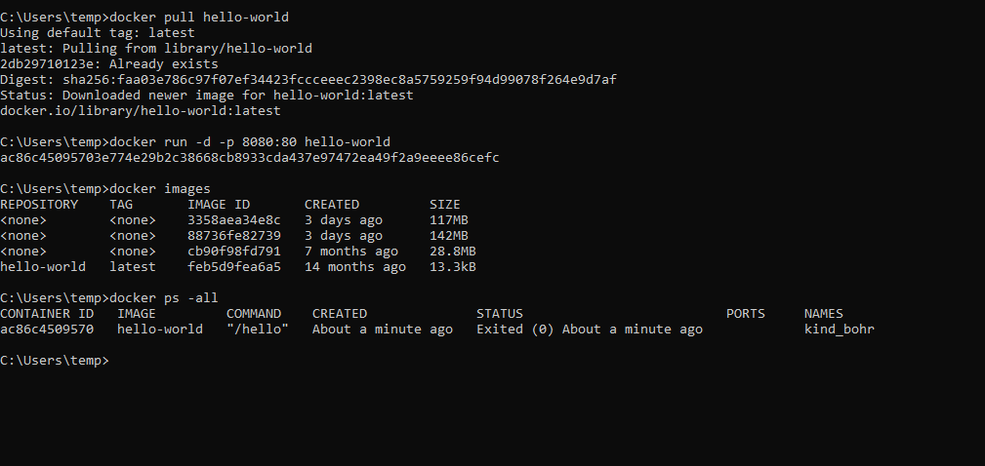

Creating fast api application and building docker image

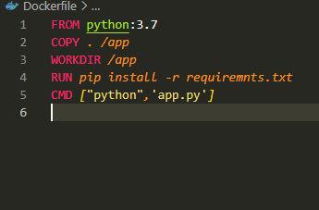

After creating a tag push into the hub

In the docker hub it will look like these



You can pull the container and again run in your local repository.

Automate the task using GitHub action for building docker image and pushing it to the Docker hub.

Following steps involved to automate the github repository

1.create a github repository

2.compose a Docker file goto actions create docker image

3.Create and edited docker image

Create a docker token

In order to create a token to go to your docker hub settings security access a token there

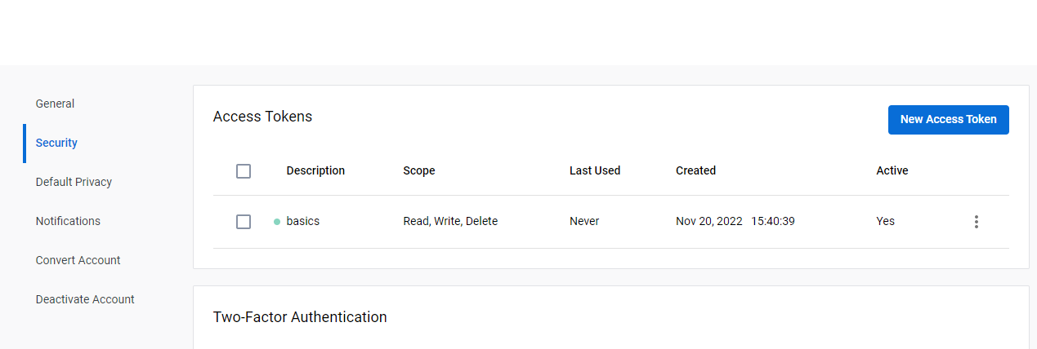

6.And there create a Github Secret in your git hub repo

Created a GitHub secret whenever you a change a name docker file it will automatically generates in the Docker Hub.

After creating it will look like these.

